SDT 213

Academic Scheduling
Phase 1: Requirements, User Guide and Project Schedule

Team 3
Kateryna Abramova, Mykhailo Kustov, Maksym Ovcharenko
Fall 2026

Instructor
V. Kolesnikov

Project Overview
The Academic Scheduling module enables universities to manage class schedules, exams, rooms, equipment, and instructor availability. The system helps prevent scheduling conflicts and provides calendar views for students, instructors, and scheduling staff.

Introduction
This Academic Scheduling platform is one module of a larger university system that combines a modern learning management system (LMS) with core campus systems: student registration and records, academic scheduling, and core platform administration. Each of these is implemented as a separate service, tied together through a shared Core Platform for authentication and a Student Information System (SIS) for enrollment data; how our module fits into that architecture is described further in the requirements section below.
Our module is responsible for academic scheduling: building and managing class and exam timetables, allocating rooms and equipment, and tracking faculty availability. Its purpose is to give the university a single, reliable view of when and where every class, exam, and resource is scheduled, and to catch scheduling conflicts - such as double-booked rooms or overlapping instructor assignments - before they reach students or faculty.

Functional Requirements
Timetable Management
Create, edit, copy, and delete class and exam timetables for each academic term.
Assign course sections to time slots, rooms, and instructors, with a draft and published status.
Support recurring weekly meetings, one-time events, and exam scheduling.
Room and Facility Booking
Maintain a catalog of rooms with building, capacity, type (lecture hall, lab, seminar room), and equipment.
Accept, approve, and cancel room booking requests for classes, exams, and campus events.
Search for available rooms by time, capacity, and equipment.
Conflict Detection
Detect room double-booking, instructor overlaps, and student-group clashes when a schedule is created or changed.
Flag rooms whose capacity is smaller than the enrollment reported by the SIS.
Display conflicts with a clear explanation and the affected sections.
Calendar Views
Provide day, week, and term calendar views for students, faculty, rooms, and administrators.
Allow filtering by course, instructor, room, and building, and export to standard calendar formats.
Non-Functional Requirements
Security
All access requires a valid JWT from the Core Platform. Role-based access control restricts editing to authorized administrators, and sensitive data is protected in transit (HTTPS).
Performance
Conflict detection re-runs and the affected conflict list updates within a few seconds of a schedule change, and the timetable grid and calendar views load without a noticeable delay under normal use, so a Scheduler sees the effect of a change immediately rather than working blind.
Reliability and Data Integrity
Bookings are handled transactionally so two users cannot reserve the same room or instructor at the same time. Daily database backups are kept.
Usability
Every conflict is explained in plain language with the affected sections named, not just an error code, and core Scheduler actions - placing a section, approving a booking, resolving a conflict - are reachable within a few clicks from the corresponding screen, so no separate documentation is needed to interpret or act on them.
Maintainability
The module is a separate Spring Boot service with a layered architecture.

System Architecture
- The system shall be implemented as a Spring Boot service with a layered architecture (presentation, service, data access), consistent with the module being a separate service from the rest of the platform.
- The system shall expose its functionality through a REST API; the web UI (Timetable Builder, Conflicts, Rooms & Equipment, My Teaching, My Calendar) shall be a client of that API, not a monolith with the business logic embedded in the view layer.
- The system shall be client-server, with all schedule, room, equipment, and booking data held on a server maintained centrally, not cached as the source of truth on any client.
- The system shall interoperate with the Core Platform for authentication and with the Student Information System (SIS) for enrollment data; it shall not duplicate or become the system of record for data owned by either.

Data Model
- The system shall maintain, at minimum, the following entities: Term (with Draft/Published status), Section (course, meeting pattern, room, instructor, linked equipment needs), Room (building, capacity, type, fixed equipment, status), Equipment (type, unit count, home location, status), Booking (requester, resource type, resource, time window, status), Instructor Availability (per term, per day/time block: Open/Prefer/Unavailable), Conflict (type, severity, affected records, resolution state), and Notice (recipient, trigger event, read state).
- A Section shall reference exactly one Room and one or more Instructors for a given meeting pattern, and may optionally reference one or more Equipment items.
- A Booking shall reference exactly one resource (a Room or an Equipment item, not both), so that room bookings and equipment bookings can share one queue without ambiguity.
- Instructor Availability shall be scoped to a single term and shall become read-only once that term is Published, so a later change cannot retroactively invalidate an already-live schedule.
- A Conflict record shall reference the specific entities that caused it (e.g., two Sections, or a Section and an Availability block), not just a free-text description, so that "Open in timetable" and "Reassign" actions can act on it directly.

Roles and Access Control
- The system shall support, at minimum, three internal roles: Student, Instructor, and Scheduler. System Administrator functions (user, role, and configuration management) shall remain the responsibility of the Core Platform and shall not be duplicated inside this module.
- The system shall not expose a control that lets a user act under a different role than their account holds.
- Access shall be enforced at the API layer, not only hidden in the UI: a request to edit a timetable, approve a booking, or resolve a conflict shall be rejected server-side if the caller's role does not permit it, regardless of what the client sends.
- Student accounts shall have read-only access to their own calendar and notices, and no access to any other student's records, any room/equipment administration screen, or any conflict data.
- Instructor accounts shall have read access to their own teaching schedule and workload, and write access limited to their own availability submissions and equipment requests.
- Scheduler accounts shall have read/write access to timetables, rooms, equipment, and bookings for the terms and clinics/departments they are authorized for, and read access to the availability submitted by instructors.

Interfaces
- The system shall provide a web-based, forms-and-grid interface for interactive use (timetable grid, catalogs, calendars), and a REST API for the same operations, so the interface is not the only way to integrate with the system.
- The system shall accept a valid Core Platform authentication token on every API request and shall reject requests without one; it shall not implement its own separate login.
- The system shall provide calendar export in at least one standard interchange format (.ics) in addition to any proprietary in-app view, so a student's or instructor's calendar can be consumed by external calendar applications.
- The system shall provide an interface for receiving enrollment figures from the SIS, used specifically for the Capacity exceeded conflict check; this interface shall be read-only from this system's side.
- The booking interface shall treat "Room" and "Equipment" as two resource types behind one shared request/approval interface, rather than as two unrelated features, so that adding further resource types in future does not require a new screen or endpoint family.

Conflict Detection Engine
- The system shall re-run conflict detection automatically whenever a Section, Booking, or Availability record is created or changed, and shall additionally support an on-demand full re-scan of a term.
- The system shall detect, at minimum: Room double-booking, Instructor overlap, Instructor unavailability, Equipment double-booking, Capacity exceeded, and Student-group clash.
- Each conflict type shall carry a severity (High, Medium, or Low); Room double-booking, Instructor overlap, and Instructor unavailability shall be High as each represents a commitment that cannot physically be honored.
- An instructor's Prefer availability blocks shall never generate a conflict; they shall be exposed to the Scheduler only as an advisory signal.
- Publishing a term with an unresolved High-severity conflict shall require explicit confirmation; publishing shall not be silently blocked, since a Scheduler may have a legitimate reason to proceed.
- Conflict detection (this engine) and booking prevention (below) shall be understood and implemented as two distinct mechanisms: detection flags problems that already exist in the schedule; prevention stops certain problems from being created in the first place.

Data Integrity
- Room and equipment bookings shall be handled as atomic database transactions, such that two concurrent approvals for the same resource and overlapping time cannot both succeed; the second shall be rejected with an explanation.
- The system shall log all conflict dismissals (who, when, which conflict) so that an overridden warning remains auditable rather than silently disappearing.
- The system's own data shall be backed up on the same schedule as the rest of the platform's data; this module shall not maintain a separate backup regime.

User Guide
Roles covered: Student, Instructor, Scheduler. (System Administrator functions — users, roles, configuration — are managed in the Core Platform, outside this module.)
This module gives the university a clear, reliable view of when and where every class, exam, room, and piece of equipment is in use, and catches scheduling conflicts before they reach students or faculty. This guide is organized by role: jump to the section for the role whose task you need.
Student: views a personal class/exam calendar and receives change notices. Primary screen: My Calendar.
Instructor: views teaching schedule, submits availability and equipment needs, reviews workload. Primary screen: My Teaching.
Scheduler: builds/edits timetables, manages room and equipment bookings, resolves conflicts. Primary screens: Timetable Builder, Conflicts, Rooms & Equipment.
Whether an Instructor can book rooms and equipment directly or must route requests through a Scheduler depends on how a given university structures its scheduling office; both flows are supported by the same Rooms & Equipment screen.

1. Signing in
Role is tied to identity, not a setting inside the app: signing in with a Core Platform account takes you straight to the screens for your own role, with no visible switch between roles once inside. To change which account you're viewing, use Switch account at the bottom of the sidebar to return to this screen and choose again.
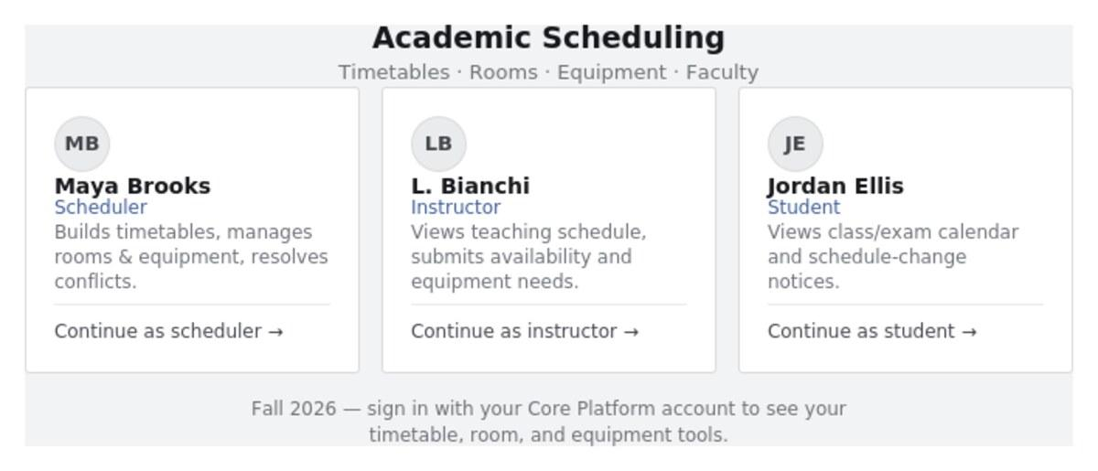
Figure 1 – Sign In Screen

2. Scheduler — Timetable Builder
Assigns course sections to time slots, rooms, and instructors for a term. Each term starts in Draft status, visible only to Schedulers; selecting Publish term makes it visible to everyone.
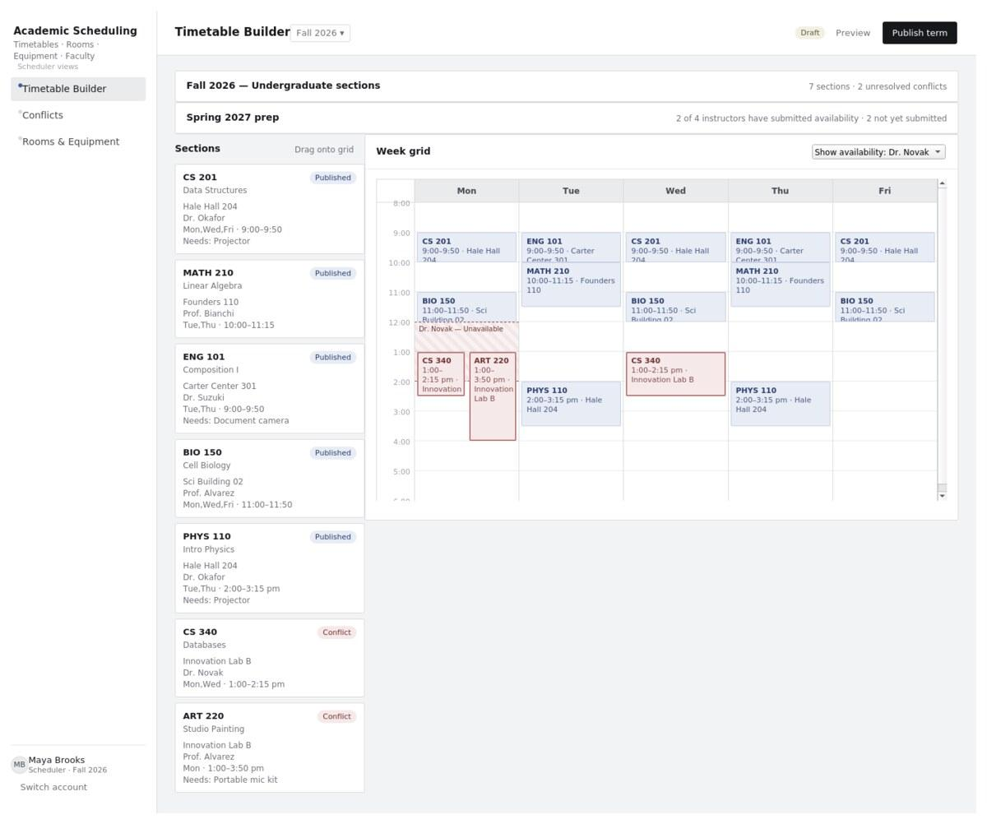
Figure 2 – Timetable Builder
Steps: select Timetable Builder → confirm the term → find the section in the list → drag it onto the grid (or set day/time directly) → mark it as weekly, one-time, or exam → save (conflicts are checked automatically against every other section, room, instructor, equipment item, and each instructor's submitted availability) → Publish term when ready.
Availability lens: the Show availability control above the grid overlays an instructor's declared Unavailable and Prefer windows directly on the week grid, so a Scheduler can see a clash while placing a section rather than discovering it afterward as a conflict card.
Copying a term: a Scheduler can copy an existing term's timetable as a starting point for a new one; the copy is created as a new Draft, so the source term's published schedule is unaffected.

3. Scheduler — Conflicts
Every schedule change is checked automatically. This screen lists everything currently flagged, in plain language, with the sections involved.
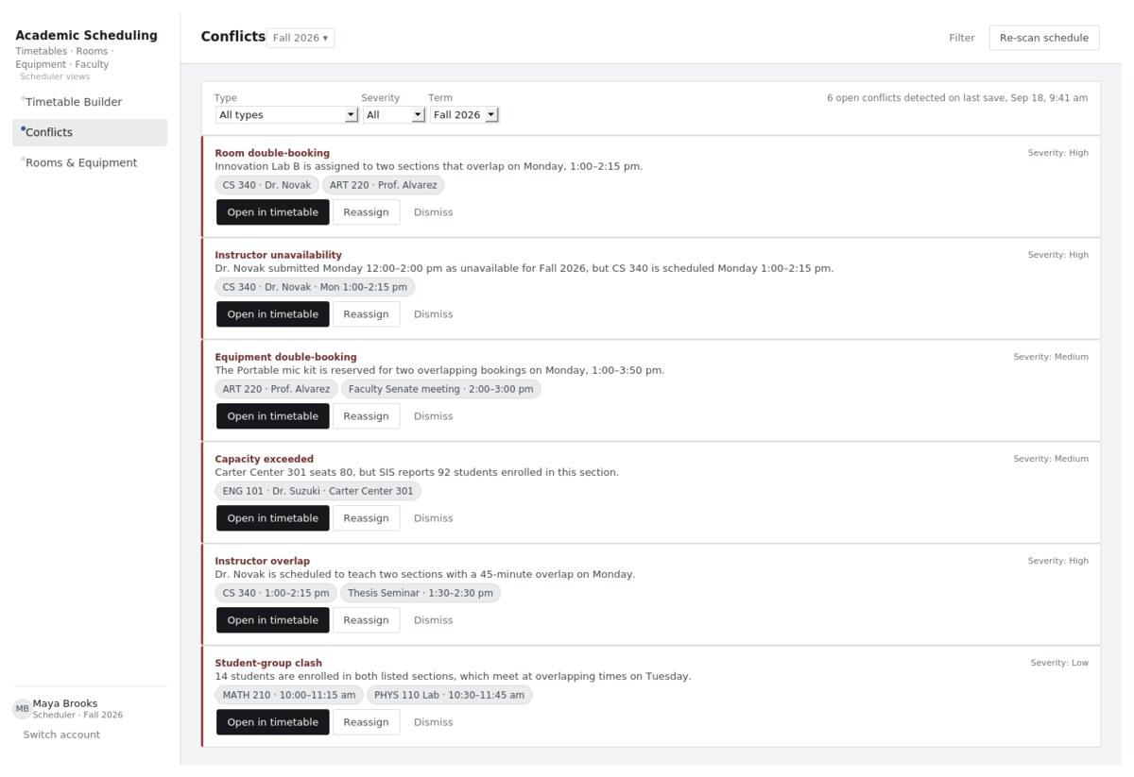
Six conflict types, each with an explanation, affected sections, and one-click actions.
Room double-booking: two sections/exams/events assigned to the same room with overlapping times.
Instructor unavailability: a section is scheduled inside a window the instructor submitted as unavailable for that term.
Equipment double-booking: the same portable item (e.g. a projector) reserved for two overlapping bookings.
Instructor overlap: the same instructor assigned to two overlapping meetings.
Student-group clash: a meaningful number of the same students enrolled in two overlapping sections.
Capacity exceeded: room capacity is smaller than SIS-reported enrollment.

Steps
Open Conflicts → filter by type/severity/term if needed → read a card's explanation and affected sections → Open in timetable to jump to the slot and move a section or item, or Reassign to fix it inline, or Dismiss if it isn't a real problem → Re-scan schedule after a batch of changes. Publishing a term with unresolved High-severity conflicts prompts a confirmation first.
An instructor's Prefer blocks are never flagged as conflicts - they're a soft signal a Scheduler can use to choose between otherwise-equal placements, not a rule to enforce. Once a term is published, the availability that fed it is locked as read-only, so an instructor updating their preferences afterward can't retroactively invalidate a schedule that's already live.
Severity, and why
Room double-booking, Instructor overlap, and Instructor unavailability are High, each commits a room or instructor to something that literally cannot happen. Equipment double-booking and Capacity exceeded are Medium - real problems, but less immediately unworkable. Student-group clash is Low - worth noticing, but often unavoidable in a small program.
Detection vs. prevention
Conflict cards catch problems that already made it into the schedule, typically from a direct timetable edit - this is a safety net, not a lock, which is why a Draft can still be saved with conflicts open. Room and equipment bookings made through the Rooms & Equipment screen carry a separate, stronger guarantee: because those bookings are transactional, two overlapping approvals for the same room or item can never both succeed in the first place. Detection and prevention are two different layers doing two different jobs.
Downstream effect
Resolving a conflict that changes a student's room or time automatically produces a notice on that student's My Calendar screen (Section 6) - the same mechanism used for any other schedule change.

4. Scheduler — Rooms & Equipment
Maintains the room catalog (building, capacity, type, fixed equipment) and a separate equipment catalog for portable items - projectors, laptop carts, mic kits - that are checked out to a person for a specific window rather than fixed in a room. The screen lets anyone with booking rights search either catalog for availability, and gives the Scheduler one shared queue of room and equipment requests to approve or cancel. A room or item can be set to Maintenance/Checked out to remove it from search without deleting its booking history.
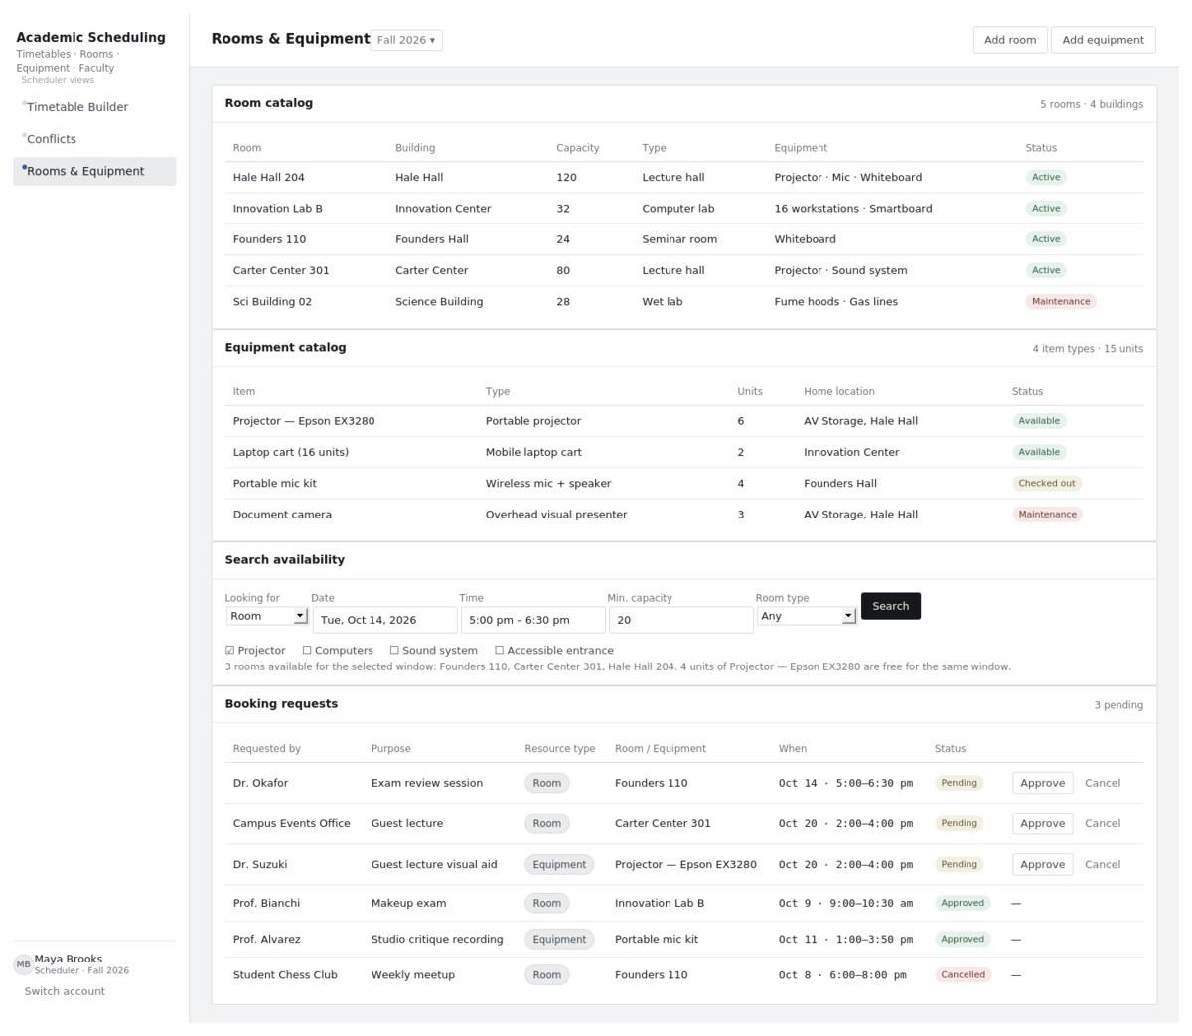
Figure 4 – Rooms & Equipment

Search
Choose Room or Equipment under Looking for, set date/time and any other filters (capacity and room type for rooms), then Search - results list everything free for the whole window that matches every filter.
Approve/cancel a request
Open Booking requests, review requester/purpose/resource/time, then Approve (reserves the room or item and re-runs conflict detection) or Cancel (requester is notified). Bookings are transactional, so two overlapping approvals for the same room or item can never both succeed.

5. Instructor — My Teaching
Brings together an instructor's teaching schedule, workload summary, and a form to submit availability and equipment needs for the next term.
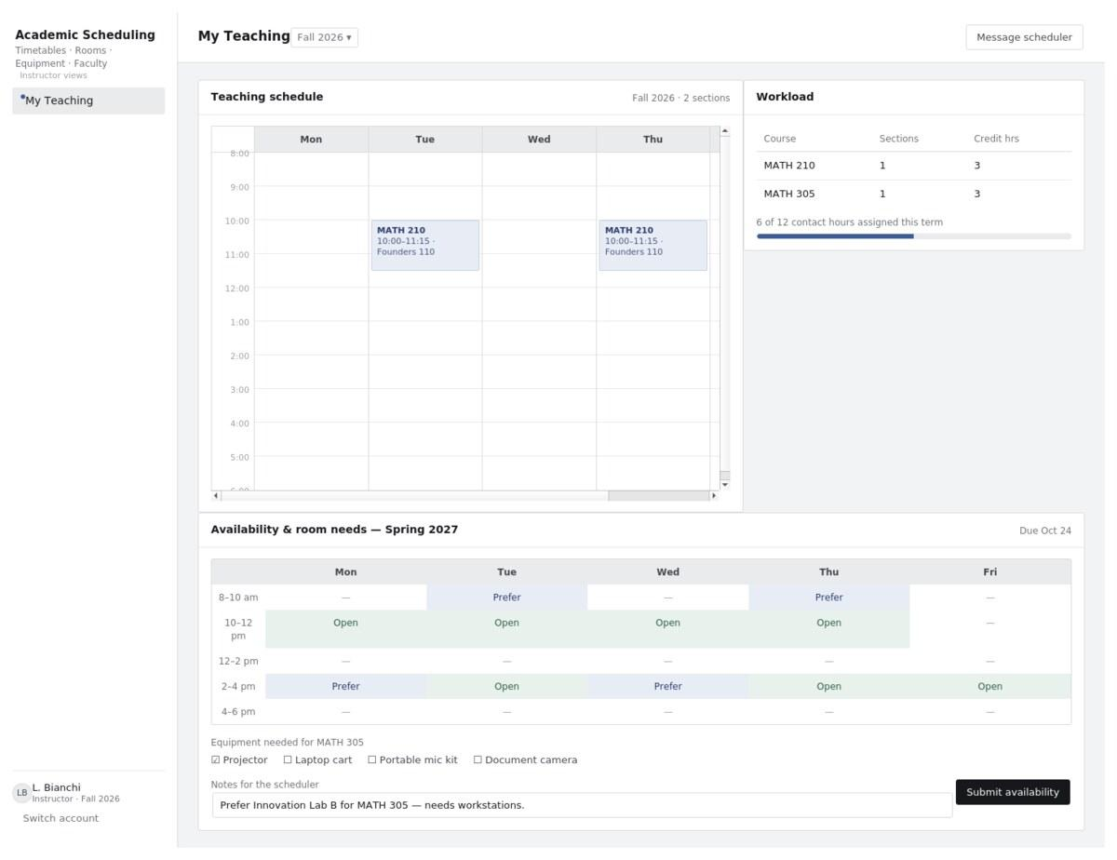
Figure 5 – My Teaching
Steps
Review your schedule and workload on this screen; for the next term, set each day/time block to Open, Prefer, or unavailable, check off any equipment a course needs (projector, laptop cart, mic kit, document camera), add any notes for the Scheduler, and select Submit availability. Once submitted, Unavailable blocks are enforced automatically - the Scheduler sees them as a conflict if a section is placed there - while Prefer blocks remain a soft signal only. Where a university allows self-service booking, the same Rooms & Equipment screen from Section 4 is available to instructors too.

6. Student — My Calendar
A personal view of every class meeting and exam a student is enrolled in, plus notices about schedule changes that affect them.
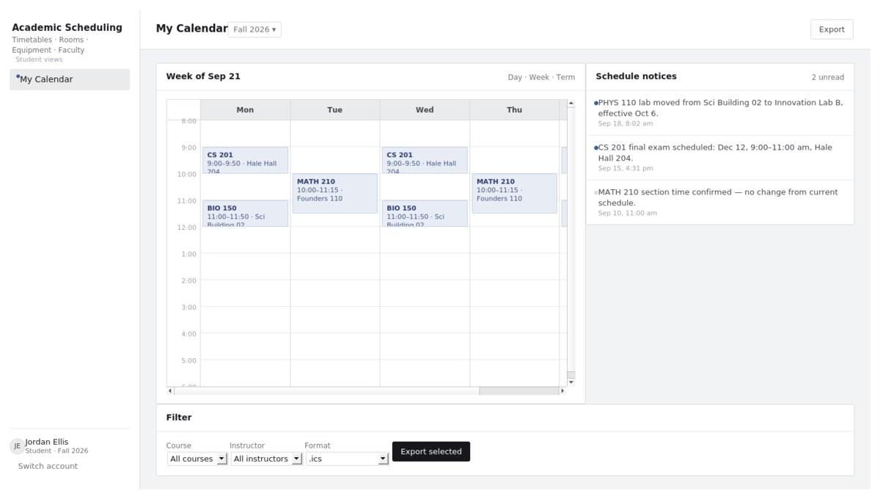
Figure 6 – My Calendar
Steps
Switch between Day/Week/Term views, filter by course or instructor, and export to .ics or Google Calendar from the Filter panel. Any room/time change, cancellation, or exam detail affecting an enrolled section produces a notice beside the calendar; unread notices show a solid dot.
7. Access, reliability, and status tags
All access requires a valid sign-in token from the Core Platform, over HTTPS. What you can see and edit is role-based: only Schedulers edit timetables and approve bookings. Room, equipment, and instructor bookings are handled as database transactions, so two people can never successfully double-book the same room, item, or instructor - one request is always rejected with an explanation. The database is backed up daily.
“Published” Visible to students and instructors. “Draft” still being built; Schedulers only. “Conflict” Needs a Scheduler's attention before publishing.

Project Schedule
Jira space: Link
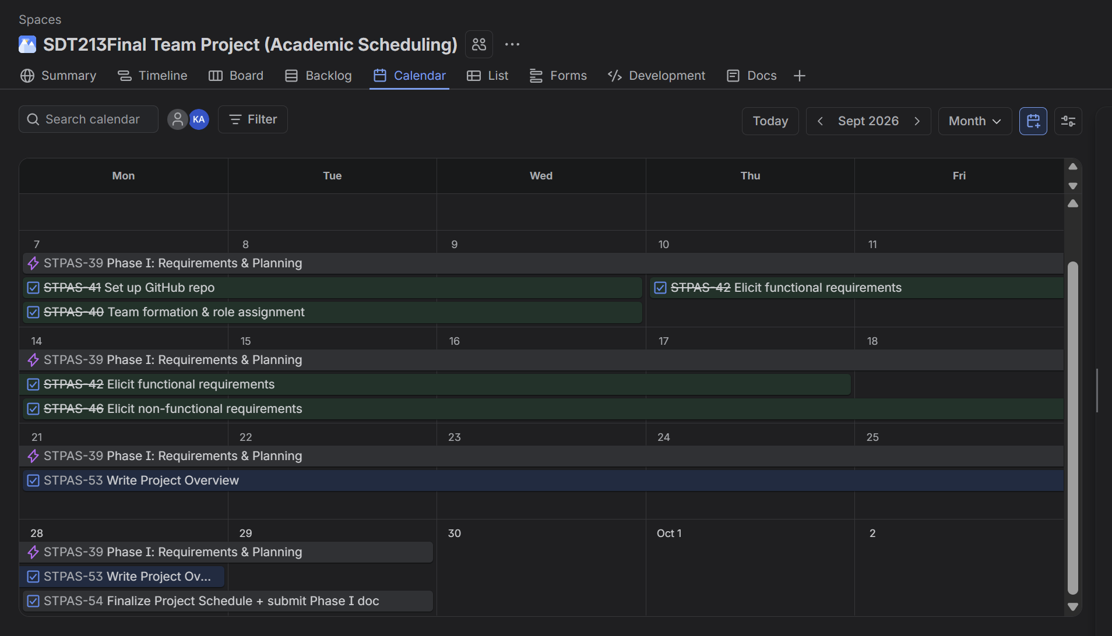
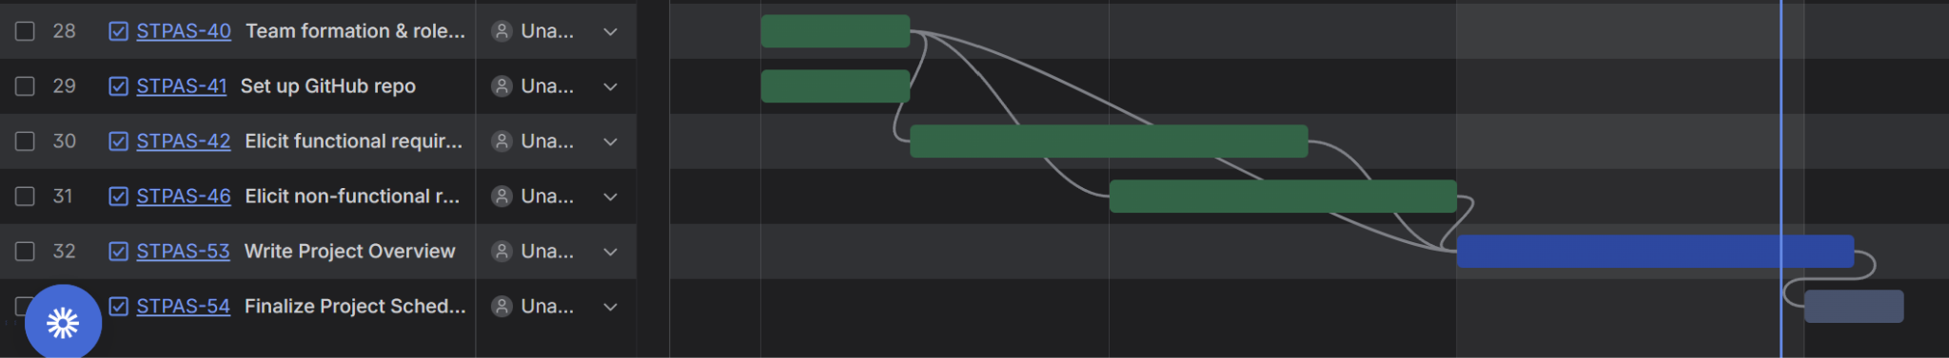
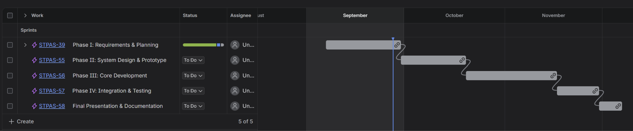

GitHub Repository: GitHub link

